### 

To create a new project, do the following:

1. Go to the **Manage resources** page in the Cloud Console.  
   [Go to the Manage Resources page](https://console.cloud.google.com/cloud-resource-manager" \t "console)
2. On the **Select organization** drop-down list at the top of the page, select the organization in which you want to create a project. If you are a free trial user, skip this step, as this list does not appear.
3. Click **Create Project**.
4. In the **New Project** window that appears, enter a project name and select a billing account as applicable. A project name can contain only letters, numbers, single quotes, hyphens, spaces, or exclamation points, and must be between 4 and 30 characters.
5. Enter the parent organization or folder in the **Location** box. That resource will be the hierarchical parent of the new project.
6. When you're finished entering new project details, click **Create**.

Complete the following steps to create a new storage bucket:

1. In the Google Cloud Console, go to the Cloud Storage **Browser** page.

[Go to Browser](https://console.cloud.google.com/storage/browser)

1. Click **Create bucket**.
2. On the **Create a bucket** page, enter your bucket information. To go to the next step, click **Continue**.
   * For **Name your bucket**, enter a name that meets the [bucket name requirements](https://cloud.google.com/storage/docs/naming-buckets).
   * For **Choose where to store your data**, select a [**Location type**](https://cloud.google.com/storage/docs/locations) and [**Location**](https://cloud.google.com/storage/docs/locations#available-locations) where the bucket data will be permanently stored.
   * For **Choose a default storage class for your data**, select a [storage class](https://cloud.google.com/storage/docs/storage-classes) for the bucket. The default storage class is assigned by default to all objects uploaded to the bucket.

**Note:** The **Monthly cost estimate** panel in the right pane estimates the bucket's monthly costs based on your selected storage class and location, as well as your expected data size and operations.

* + For **Choose how to control access to objects**, select whether or not your bucket enforces [public access prevention](https://cloud.google.com/storage/docs/public-access-prevention), and select an [**Access control** model](https://cloud.google.com/storage/docs/access-control) for your bucket's objects.

**Note:** If public access prevention is already enforced by your project's [organization policy](https://cloud.google.com/storage/docs/org-policy-constraints#public-access-prevention), the **Prevent public access** toggle is locked.

* + For **Choose how to protect object data**, configure **Protection tools** if desired, and select a [**Data encryption** method](https://cloud.google.com/storage/docs/encryption).

1. Click **Create**.

### Activate Cloud Shell

Cloud Shell is a virtual machine that contains development tools. It offers a persistent 5-GB home directory and runs on Google Cloud. Cloud Shell provides command-line access to your Google Cloud resources. gcloud is the command-line tool for Google Cloud. It comes pre-installed on Cloud Shell and supports tab completion.

1. In the Google Cloud Console, in the navigation pane, click **Activate Cloud Shell** (image).
2. Click **Continue**. It takes a few moments to provision and connect to the environment. When you are connected, you are also authenticated, and the project is set to your *PROJECT_ID*. For example:

#### **Sample commands**

* List the active account name:

gcloud auth list

* List the project ID:

gcloud config list project

## **Enable Cloud Services**

1. In Cloud Shell, to set the project ID to your Google Cloud Project, run the following command:

export PROJECT_ID=$(gcloud config get-value core/project)

gcloud config set project $PROJECT_ID

1. To enable the required Cloud services, run the following commands:

gcloud services enable \

cloudbuild.googleapis.com \

container.googleapis.com \

cloudresourcemanager.googleapis.com \

iam.googleapis.com \

containerregistry.googleapis.com \

containeranalysis.googleapis.com \

ml.googleapis.com \

dataflow.googleapis.com

1. Add the Editor permission for your Cloud Build service account:

PROJECT_NUMBER=$(gcloud projects describe $PROJECT_ID --format="value(projectNumber)")

CLOUD_BUILD_SERVICE_ACCOUNT="${PROJECT_NUMBER}@cloudbuild.gserviceaccount.com"

gcloud projects add-iam-policy-binding $PROJECT_ID \

--member serviceAccount:$CLOUD_BUILD_SERVICE_ACCOUNT \

--role roles/editor

## 

## **Create an instance of AI Platform Pipelines**

You will be deploying Kubeflow Pipelines as a Kuberenetes App, which are solutions with simple click to deploy to Google Kubernetes Engine, and the flexibility to deploy to Kubernetes clusters on-premises or in third-party clouds. You will see Kubeflow Pipelines integrated into your Google Cloud environment as **AI Platform Pipelines**.

1. In the Google Cloud Console, on the Navigation menu, scroll down to **AI Platform** and pin the section for easier access later in the lab.
2. Click **Pipelines**.
3. Then click **New Instance**.
4. Click **Configure**.

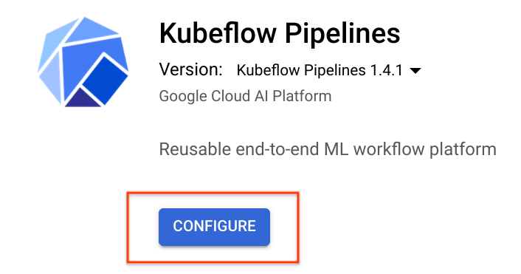

1. Check **Allow access to the following Cloud APIs**, leave the name as is, and then click **Create Cluster**.

While you wait for the cluster to be created, do one of the following:

* On the **Navigation menu**, click **Kubernetes Engine** to view the cluster being created.
* On the **Navigation menu**, click **Compute Engine** to see the individual VMs spinning up.

1. When the cluster creation is complete, check the **Terms of Service** box, leave other settings unchanged, and then click **Deploy**. You will see the individual services of KFP deployed to your GKE cluster. Wait for the deployment to finish before proceeding to the next task.

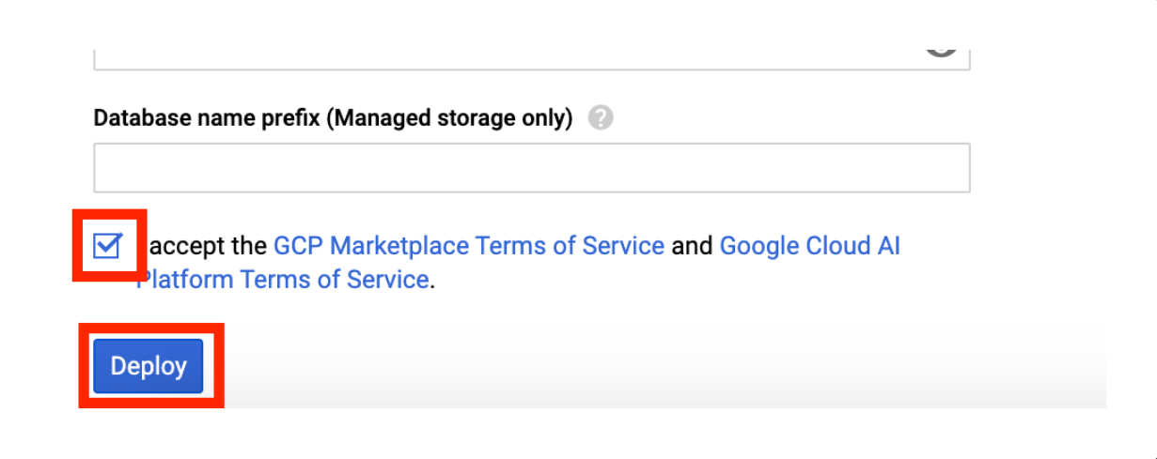 **Create an instance of Vertex AI Platform Notebooks**

An instance of Vertex AI Platform Notebooks is used as a primary experimentation/development workbench. The instance is configured using a custom container image that includes all Python packages required for this lab.

Wait for instance of Vertex AI Platform Notebooks.

This may take up to 5 minutes to complete.

1. After five minutes, in the Cloud Console, on the **Navigation menu**, click **Vertex AI > Workbench**. The notebook instance you created in the previous step will be listed.
2. Click the **Open Jupyterlab** link.

**NOTE** The Vertex AI Platform Notebooks instance will take 4 or 5 minutes to reflect on the Vertex AI Platform page.

## **Clone the repo within your Vertex AI Platform Notebooks instance**

1. In JupyterLab, click the **Terminal** icon to open a new terminal.
2. In the terminal, to navigate to jupyter director, run the following command:

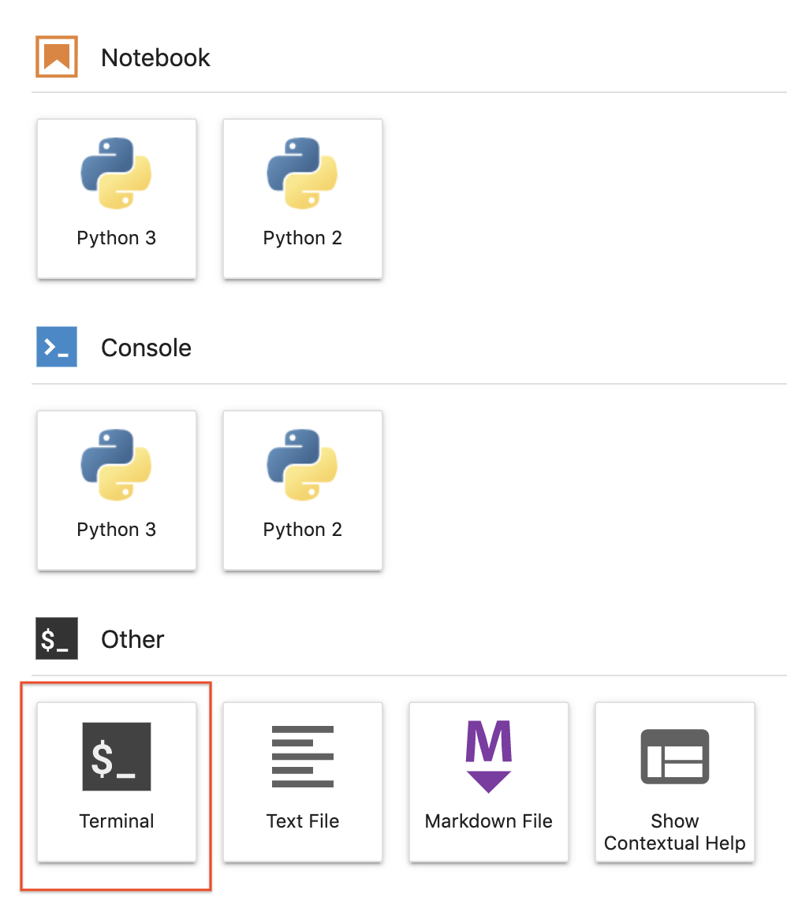

**Step 2**

Use the top line menu and under **Git** --> **Clone a repository**, clone the repo using the UI.

